SAMPLE PAPER - 2013

CBSE CLASS-XII

**SUBJECT: PHYSICS**

***MM MARKS: 70] [TIME: 3 HOUR***

General Instructions:

* *All the questions are compulsory*
* *Question no. 1 to 8 consist of one marks questions, which are very short answer type questions.*
* *Question no. 9 to 16 consist of two marks questions, which are short answer type questions.*
* *Question no. 17 to 25 consists of three marks questions, which are long answer type questions.*
* *Question no. 26 consists of four mark question.*
* *Question no. 27 to 29 consists of five marks question, which are very long answer type question.*
* *There is no overall choice given. However internal choice is given in one questions of two marks, one questions of three marks and all the three questions of five marks.*
* *You have to attempt only one choice in such question.*
* *Use of calculators is not permitted.*
* *You may use the value of the following physical constants:*

|  |  |
| --- | --- |
| **Speed of light (c)** | **3 × 108m/s** |
| **Plank’s constant( h)** | **6.626 × 10-34Js** |
| **Electric charge (e)** | **1.602 × 10-19C** |
| **Permeability for free space** | **4π × 10-7Tm/A** |
|  | **9 × 109Nm2/C2** |
| **Mass of Neutron (mN)** | **1.67 ×10-27Kg** |
| **Mass of proton (mP)** | **1.67 ×10-27Kg** |
| **Mass of electron (me)** | **9.10 ×10-31Kg** |
| **Boltzmann’s constant (k)** | **1.38 × 10-23J/K** |
| **Avogadro number (NA)** | **6.022 ×1023/ mole** |

1. In uniform electric field of strength E, a charges particle Q moves point A to a point B in the direction of the field and back from B to A. Calculate the ratio of the work done by the electric field in taking the charge particle from A to B and from B to A.
2. A battery of emf 2.0 volts and internal resistance 0.1 ohm is charged with a current of 5.0A. What is the potential difference between the terminals of the battery?

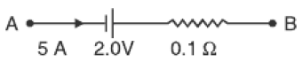

1. A carrier wave of peak voltage 12V is used to transmit a message signal. What should be the peak voltage of the modulating signal in order to have a modulation index of 75%.

**PTO (042)**

1. In a young’s double slit experiment, two disturbances arriving at a point P have a phase difference of π/3. What is the intensity at this point expresses as a fraction of maximum intensity Io.
2. In the figure shown coils P and Q are identical and moving apart with the same velocity V. Induced current in coils are I1 and I2.Find I1/ I2

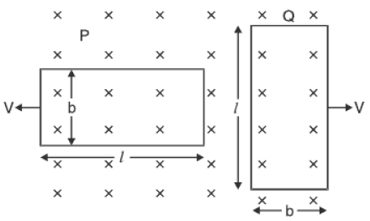

1. V-I graph for a metallic wire at two different temperatures T1 and T2 is as shown in the figure. Which of the two temperatures is higher and why?

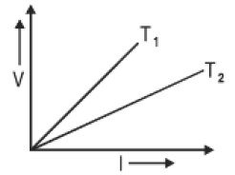

1. A particle of mass *m* and charge *q* moves at right angles to a uniform magnetic field. Plot the graph showing the variation of the radius of the circular path describes by it with the increase in the kinetic energy, where other factors remain constant.
2. A capacitor, of capacitance C is being charged up by connecting it across a dc voltage source of voltage V. How do the conduction and displacement currents, in this set up compare with each other:
3. During the charging up process.
4. After the capacitor gets fully charged.
5. An electron and proton are having the same amount of kinetic energy, which of the two have a greater de-Broglie wavelength. Justifty.If a proton is accelerated through a potential difference of V. Find the percentage increase or decrease in the de-Broglie wavelength if the potential difference is increased by 21%.
6. For an isolated parallel plate capacitor of capacitance C and potential difference V, what will happen:
7. Charge on the plates
8. Potential difference across the plates
9. Electric field between the plates
10. Energy stored in the capacitor

When the distance between the plates is increased?

1. In the following diagram, find the focal length of the lens L2.

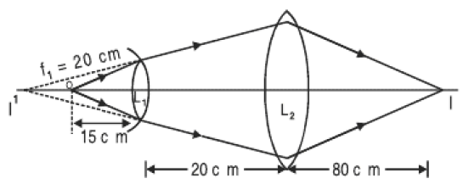

1. The following figure shows the input waveform A and B and the output waveform Y of the gate. Write its truth table, identify the logic gate and draw its symbol.

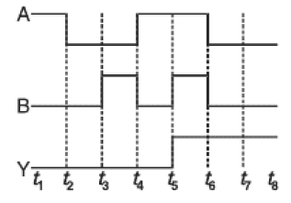

1. By how much would the stopping potential for a given photosentive surface go up if the frequency go up if the frequency of the incident radiation were to be increased from 4 ×1015Hz to 8×1015Hz.
2. A rectangular conducting loop of length *l* and breadth *b* enters a uniform magnetic field B as shown in the figure:

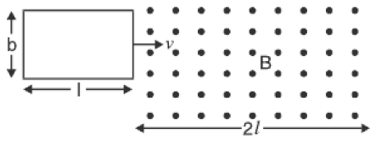

The loop is moving with a constant speed *v* and at *t*=0 it just enters the field B. Sketch the following graph for the time interval *t* = 0 to *t* = $\frac{3l}{ v}$.

1. Magnetic flux– time
2. Induced emf – time
3. Force –time
4. Power – time

Resistance of the loop is R.

1. Two identical parallel plate capacitors connected to a battery with switch S closed. The switch is now opened and the free space between the plates of the capacitors is filled with a dielectric of dielectric constant 3. Find the ratio of the total electrostatic energy stored in the both the capacitors before and after the introduction of dielectric.

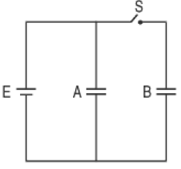

**OR**

The electric field component in the figure are Ex = 2x**i**, Ey= Ez = 0, calculate the flux through, (1, 2, 3) the square surfaces of side 5cm.

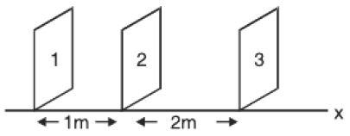

1. A potentiometer wire AB of length 1m is connected to a driver cell of emf 3V as shown in the figure. When a cell of emf 1.5V is used in the secondary circuit, the balance point is found to be at 60cm. on replacing this cell by a cell of unknown emf E, the balance point shifts to 80cm.



1. Calculate the unknown emf of the cell.
2. Explain with reason, whether the circuit works if the driver cell is replaced with a cell of emf 1V.
3. **(a)** Four nuclei of an element fuse together to form a heavier nucleus. If the process is accompanied by the release of energy. Which of the two- the parent or the daughter nucleus have a higher binding energy per nucleon? Give reason.

**(b)** The decay constant, for a radionuclide has a value of 1.386day-1. After how much time will a given sample of this radionuclide get reduced to only 6.25% of its present number?

1. **(a)** The short wavelength limits of Lyman, paschen and balmer series in the hydrogen spectrum is denoted by $λ_{L}$, $λ_{P}$ and $λ_{B}$ respectively. Arrange the following in increasing order of wavelength.

**(b)** Photons with a continuous range of frequencies are made to pass through a sample of rarefied hydrogen. The transitions as shown in the diagram which indicate three of the spectral lines in the continuous spectrum.

1. Identify the spectral series, of the hydrogen emission spectrum, to which each of these three lines correspond.
2. Which of these lines corresponds to the absorption of radiation of maximum wavelength?

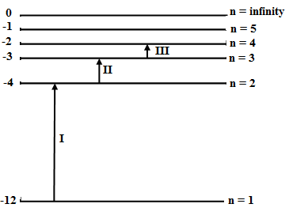

1. A plane electromagnetic wave, of angular frequency $ω$ is propagating with velocity *c* along Z-axis. Write the vector equations electric field and magnetic field and hence show this field diagrammatically.

Let the wavelength of the electromagnetic wave used quite often for:

1. Remote sensing
2. Treatment of cancer
3. Purification of water

Are $λ_{1}$, ${ λ}_{2}$ and ${ λ}_{3}$. Identify the electromagnetic waves and arrange the following in increasing order of frequency.

1. An equiconvex lens of radius of curvature of **R** each is put over a liquid layer poured on the top of the plane mirror. A small needle with its tip on the principle axis of the lens is moved along the axis until its real inverted image coincides with the needle itself. The distance of the needle from the lens is measured to be ***a***. On removing the liquid layer and repeating the experiment the distance is measured to be ***b***. given that two values of the distance measured is the focal length values in the two cases.

Obtain the formula for the refractive index of the liquid.

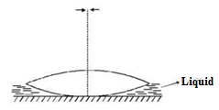

1. The electric field components due to a charge inside the cube of side 0.1m are shown. Where EX = αx, where α = 500N/C-m, EY = 0, EZ = 0. Calculate the flux inside the cube and the charge inside the cube.

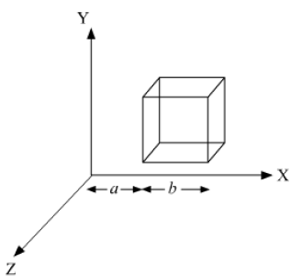

1. Is it necessary that the transmitting antenna and the receiving antenna to be of the same height for line of sight communication. By what percentage will the transmission range of a TV tower be affected when the height of the tower is increased by 44%? Why do we need satellites for TV communication?

**OR**

1. Define modulation index.
2. Give any two factors which justify the need of modulation.
3. Draw the diagram showing the amplitude modulated wave by superimposing the modulated signal over a sinusoidal carrier wave.
4. A partially plane polarized beam of light is passed through a Polaroid. Show graphically the variation of the transmitted light intensity wills the angle of the Polaroid.

Light, from a sodium lamp is passed through two Polaroids sheets P1 and P2 kept one after the other. Keeping P1 fixed, P2 is rotated so that its pass-axis can be at different angles, $θ$, with respect to the path-axis of P1.

An experimentalist records the following data for the intensity of light coming out of P2 as a function of angle $θ$. One of these observations is not in agreement with the expected theoretical variation of I. Identify this observation and write the correct expression.

|  |  |  |
| --- | --- | --- |
| **S.No.** | $θ$**(Angle Between The Pass – Axis of The Two Polaroids)** | **I ( Intensity of light coming out of P2)** |
| **1** | 0o |  |
| **2** | 30o |  |
| **3** | 45o |  |
| **4** | 60o |  |
| **5** | 90o |  |

1. For the circuit given below find the potential difference between points B and D.



1. In the given diagram, a small magnetized needle is placed at a point O. The arrow shows the direction of its magnetic moment. The other arrows shown different positions and orientations of the magnetic moment of another identical magnetic needs B.



1. In which configuration are the systems not in equilibrium?
2. In which configuration is the system
3. Stable equilibrium
4. Unstable equilibrium

Justify your answer.

1. Alka and her sister were watching a movie in which the phenomenon of ***Aurora Boriolis*** was shown. Alka could not believe her eyes that such a colorful display like the one during commonwealth games could be created by nature. She went to the library, but could not find the right book. So she consulted her teacher who guided her. Hence, Alka understood that during a solar flare, a large number of electrons and protons are ejected from the sun. Some of these get trapped in the earth’s magnetic field and move in a helical path along the field lines. As the density of the field lines increases near the poles, these particles collide with atoms and molecules of the atmosphere emitting green and pink light. Alka shared this knowledge with her class when they studied the chapter of moving charges in magnetic field.
2. What values did Alka have?
3. What is the radius of the path of an electron moving at a speed of 3 x 107 m /s in a magnetic field of 6 Gauss perpendicular to it? What is its frequency? Calculate its energy in kilo electron volt.
4. Answer the following:
5. What is a Zener diode and explain its use as a voltage regulator with the help of a circuit diagram.
6. Zener diodes have higher dopant densities as compared to ordinary p-n junction diodes. How does this affect the:
7. Width of the depletion layer.
8. Junction field.
9. In only one of the circuits given below the lamp L lights. Which circuit is it? Give reason for your answer.

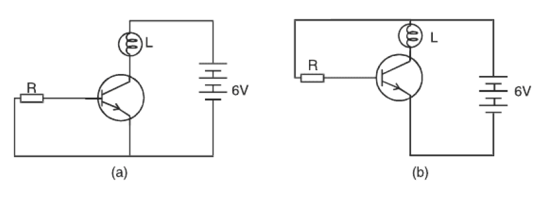

**OR**

1. Explain the *n-p-n* transistor with the help of a suitable circuit diagram and specify its biasing and its transistor action.
2. The given circuit diagram shows a transistor configuration.

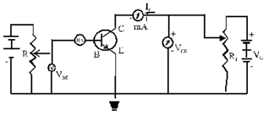

1. Identify the type of transistor configuration employed.
2. Can we interchange the emitter and the collector of the given transistor? Give reasons.
3. Determine the current I in the network. (Barrier voltage for Si diode is 0.7 volts).

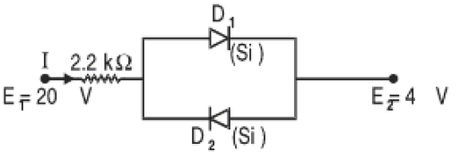

1. Answer the following:
2. Draw a well labeled diagram of an AC generator.
3. Figure (a), (b) and (c) show three alternating circuits with equal currents. If frequency of the alternating emf be increased, what will be the effect on the current in the three cases? Explain.

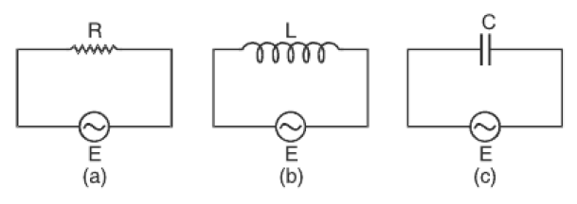

1. A bar magnet M is dropped so that it falls vertically through coil C. The graph obtained for voltage produced across the coil v/s time is shown in the figure.

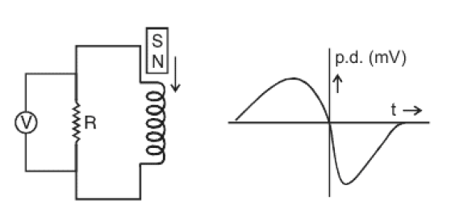

1. Explain the shape of the graph.
2. Why is the negative peak longer than the positive peak?

**OR**

1. An ac circuit consists of a series combination of X and Y. the current is ahead of the voltage in phase by π/4. If the element X is a pure resistor of 100 ohm. Name the circuit element Y and calculate the rms value of current, if the rms voltage is 141V.
2. Show that the potential difference across the LC combination is zero at the resonating frequency in the series LCR circuit.
3. Two circular conductors are perpendicular to each other as shown in the diagram. If the current is changes in the conductor B, will a current be induces in the conductor A. Give reason.

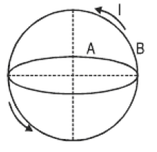

1. Answer the following:
2. Deduce the conditions for constructive and destructive interference and hence derive the expression for the distance between two consecutive bright or dark fridges. What change in the interference pattern do you observe if the two slits S1 and S2 are taken as point sources?
3. A parallel beam of light of wavelength 600nm is incident normally on a slit of width ***d***. If the distance between slits and the screen is 0.8m and the distance of 2nd order minimum from the centre of the screen is 9.5mm, calculate the width of the slit.
4. As shown in the figure, two light waves of the same frequency start from the sources S1 and S2 in the same phase. The distance between S1S2 = /2. What will be the nature of interference at the points A, B and C.?

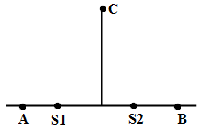

**OR**

1. Using the data given below, state which two of the given lenses will be preferred to construct telescope. Also indicate which is used as an objective and as an eyepiece.



1. Hence derive the expression for the magnifying power of an astronomical telescope when its final image forms at the least distant of vision with the help of a suitable diagram.
2. An astronomical telescope consists of two thin lenses set 36 cm apart and has a magnifying power 8. Calculate the focal length of the lenses.